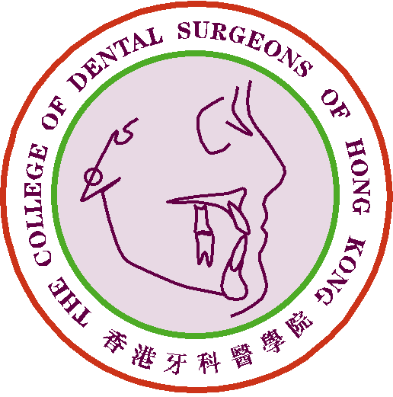
THE COLLEGE OF DENTAL SURGEONS OF HONG KONG
Claim Form for CME/CPD Programme
Report for Performing Training Duties
(For the Cycle of 2023-2025)

Part 1: Details of Applicant
Full Name:
Specialty: |  | DCHK No.:
E-mail Address: |  | Fax No.:
Phone No.: |  | Date of Submission:

Part 2: Details of Trainee(s)
Full Name of  Respective Trainee(s) | DCHK No. | Status  (e.g. Basic/ Higher Trainee) | Training Period  (e.g. mm/yyyy - mm/yyyy) | Training Center
# Please use additional forms if needed.

Part 3: Declaration by the Applicant
Signature of the Applicant
Prof./ Dr. ____________________________
Trainer, Specialty in ___________________
Date: ____________________
 I declare that all information provided in this claim form is true and correct.
Signature of the Specialty Board Chairman
Prof./ Dr. ___________________________
Chairman, Specialty Board in _______________
Date: ____________________

*According to the Principles and Guidelines on Continuing Medical Education and Continuous Professional Development (CME/CPD), with effective from 1 January 2023:
Performing Training Duties:
- Performing training duties as an approved trainer can be awarded a maximum of 10 points per trainee for a single year.
- No more than 30 points can be awarded for a single trainer per 3‐year cycle.
- No more than two trainers can claim CME for a single trainee in a single year.

- The CME Sub-committee has the right to evaluate, approve, review and revise the CME point(s) for the above activity/ activities.
- Proper trainee annual evaluation form is needed to be submitted.
- Please send the completed claim form and other supporting/relevant document by e-mail: cme_cpd@cdshk.org to College Secretariat for processing.

